Heel Pain Guide
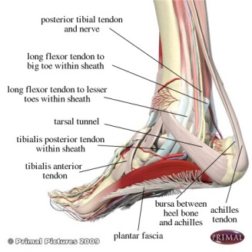

Plantar Heel Pain / Plantar Fasciitis

This is a degenerative inflammatory injury to the Plantar Fascia, which is a ligament that stretches across the arch, from the ball of the foot to the heel bone. It feels like a dull ache most of the time, but is most painful when first resuming activity such as getting out of the bed in the morning, or upon standing after sitting for a period of time.

How did this happen?
There are potentially a number of causes for the problem including:
- Weight gain
- Biomechanics (foot function)
- Occupation
- Exercise
- Footwear

It is believed that heel spurs cause this condition. This is incorrect. Heel spurs may be a consequence of the condition, but not the cause.

Recent weight gain and increased activity level often start an episode. A person who has been mostly sedentary, but then walks a lot, particularly over a short period of time is a prime candidate. A change of shoes from well supportive walking or athletic shoes to floppy sandals can cause it. Finally, conditions which cause generalised increased inflammation, like osteoarthritis or rheumatoid arthritis can cause this.

Conservative Treatment
Treatment may include: Stretching; Icing; Strapping; Orthotics; Physiotherapy; Footwear modifications; Night splints.
A week's use of an over-the-counter anti-inflammatory medication may help eliminate the pain. Recurrence is possible but rare after treatment, if the patient continues to employ good mechanical foot control by continuing to wear orthotics and good supportive walking or athletic shoes.

Non-Conservative Treatment
About 10% of all heel pain patients don’t improve with conservative treatment. If this should be the case, more aggressive treatment should be sought. This may include Cortisone injections, however this is not commonly recommended by Podiatry Point.

Lithotripsy, which is a special type of ultrasound, may also be quite helpful. Your podiatrist will be able to discuss this with you. In some cases surgery may be recommended. This is usually successful in about 70-80% of cases. Should your heel condition be significantly affecting your lifestyle and is unresponsive to conservative care then it may be worth considering.

Common Treatment Options
- Icing with a frozen water bottle
- Massage
- New footwear
- Changing foot and leg Mechanics
- Dry needling
- Local aesthetic
- Orthotics
- Exercise prescription
- Task modification
Adjunct Therapies
- FS6 sock
- Rock Tape
- Dry needling
- Foot mobilisation
- Shock wave therapy
- Cortisone injection

Ice and Massage
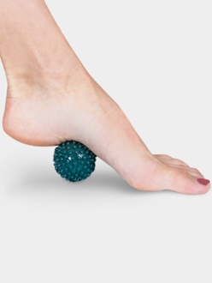
SUPPORT
FOOTWEAR

2 common stretches
Calf Stretch (straight leg)
Stand facing a wall with one foot in front of the other and with feet parallel to each other. You can place your hands on the wall for support. Keep the rear leg straight with the heel flat on the floor. Slowly lean into the wall until a stretch is felt in the calf (Picture 1 and 2)
Hold the stretch for about 20-30 seconds and repeat for the opposite leg. Repeat this stretch 3 times on each leg.

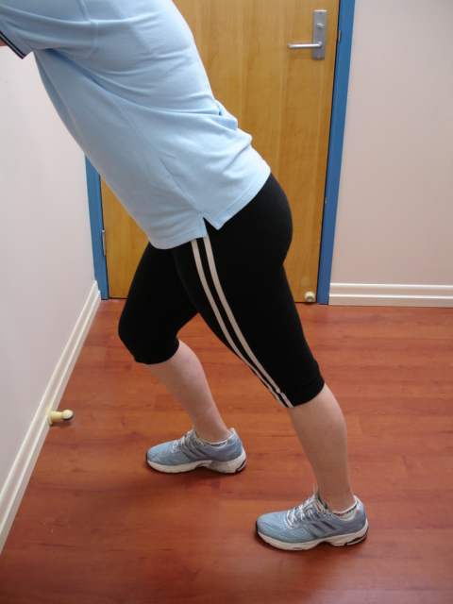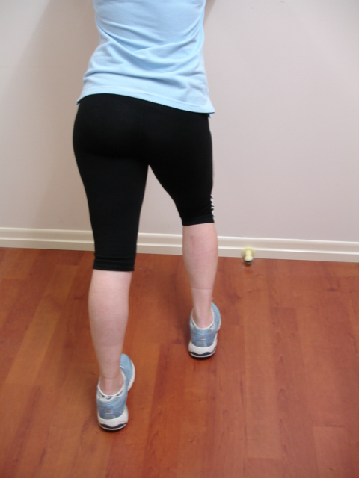
Picture 1 Picture 2

Plantar Fascial Stretch

Stand with the toes and ball of the foot against a wall. The distance between the ball of the foot and the floor should be approximately 5 cm. Gently lean your body weight towards the wall without moving your foot position (Picture 1). Make sure that the knee of the front leg is straight throughout the stretch. You should feel a stretch through the arch of the foot. You may also feel the stretch through the arch as well as the heel and lower calf.

Hold this stretch for 10 seconds.

Complete this exercise once on each foot.

Picture 1

What is a Good Shoe?
General pointers for buying shoes:
- Buy shoes at the end of your day. Your feet swell as the day goes by.
- Make a cutout of your feet when you are sitting with your feet flat on the floor and take them shopping.
- Always fit the larger foot (compare your cutouts). It’s easy to fill in space (eg innersole) but very hard to enlarge it.
- Expensive shoes are not always good shoes.
- Always try both shoes on and walk around in them. If possible walk on a hard surface (eg away from the soft carpet in the store).

Some important features to look for in a shoe:

- Push the toe and heel together: The shoe should bend where your foot bends (at the ball of the foot).
- Heel counter: The heel counter should be firm when you try and move it with your fingers.
- Lace up (3 pairs of eyelets) or velcro / buckle straps (at least 2 straps): They give the most support and allow for difference in size. In a slip-on shoe your toes must curl under (claw) to hang onto the shoe. The foot also slides forward in the shoe squashing the toes. Slip-on shoes stretch and become too loose.
- Wide enough and long enough: There should be a thumb width between the longest toe and the end of the shoe and your foot should not cause the upper to hang over the outsole of the shoe.
- Toe box – depth and shape: The toebox should be deep enough to allow room for the top of your toes, especially claw or hammer toes. Round or square is best. Pointed-toe shoes may lead to bunions.
- Outsole: A soft outsole (eg rubber) gives extra shock absorption when walking on hard surfaces. A soft innersole can also help.

Search the link below to find a video of how to apply a common type of strapping for plantar fasciitis and heel pain - Low Dye strapping.

